Phase 2. PDF eXpress verification
Create Account for the ETCM conference using 71070X as conference ID
https://ieee-pdf-express.org/account/login?ReturnUrl=%2F

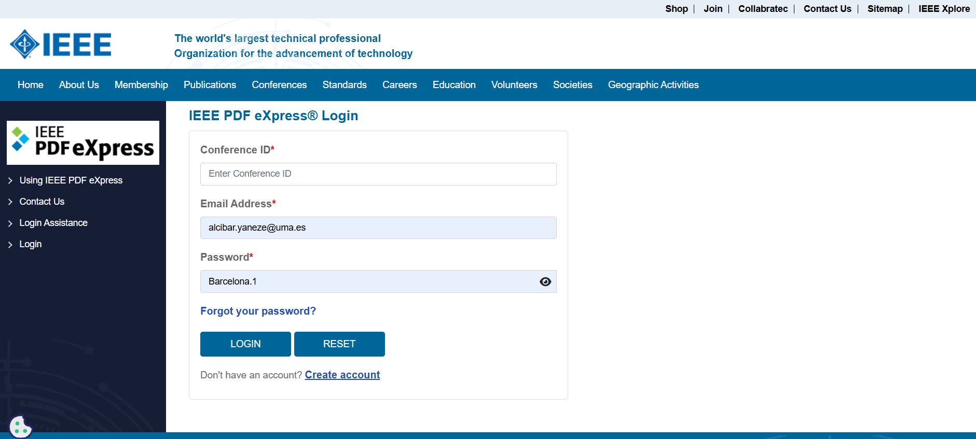

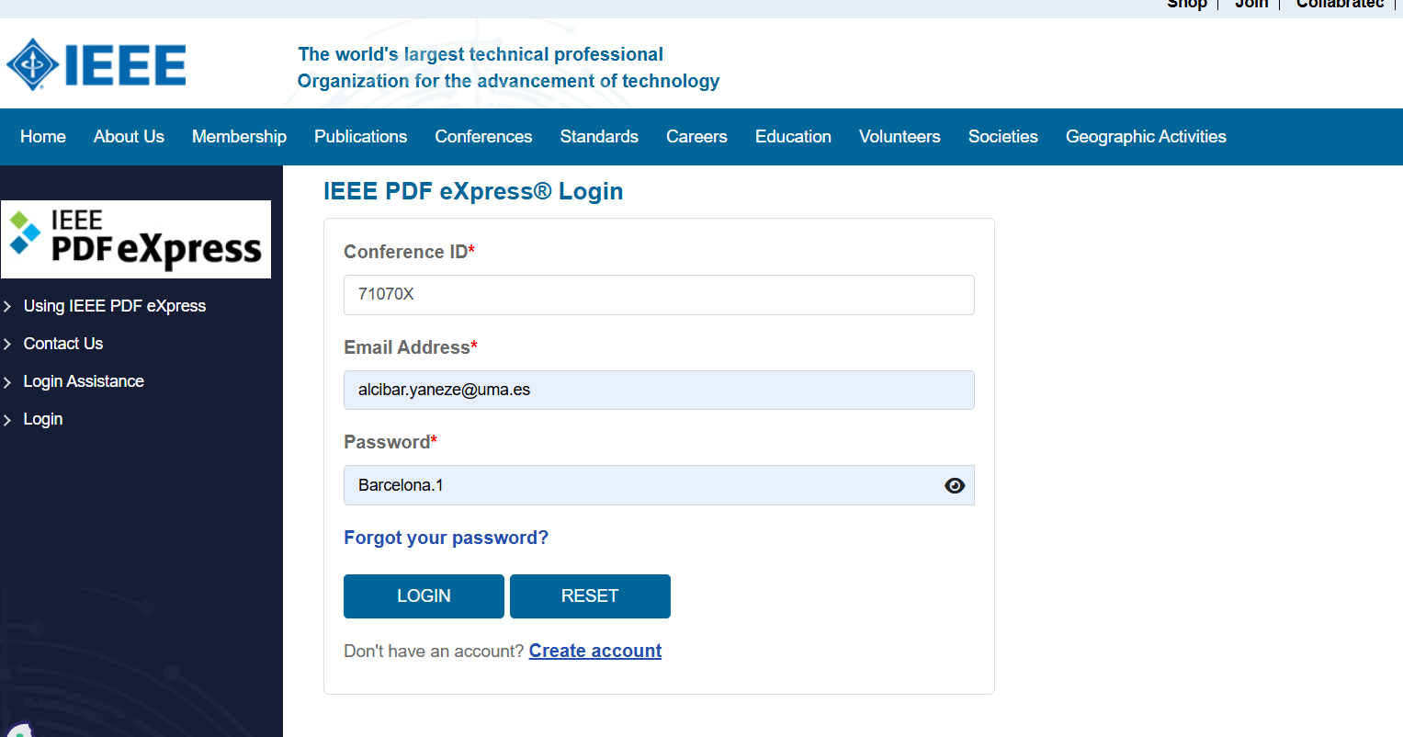

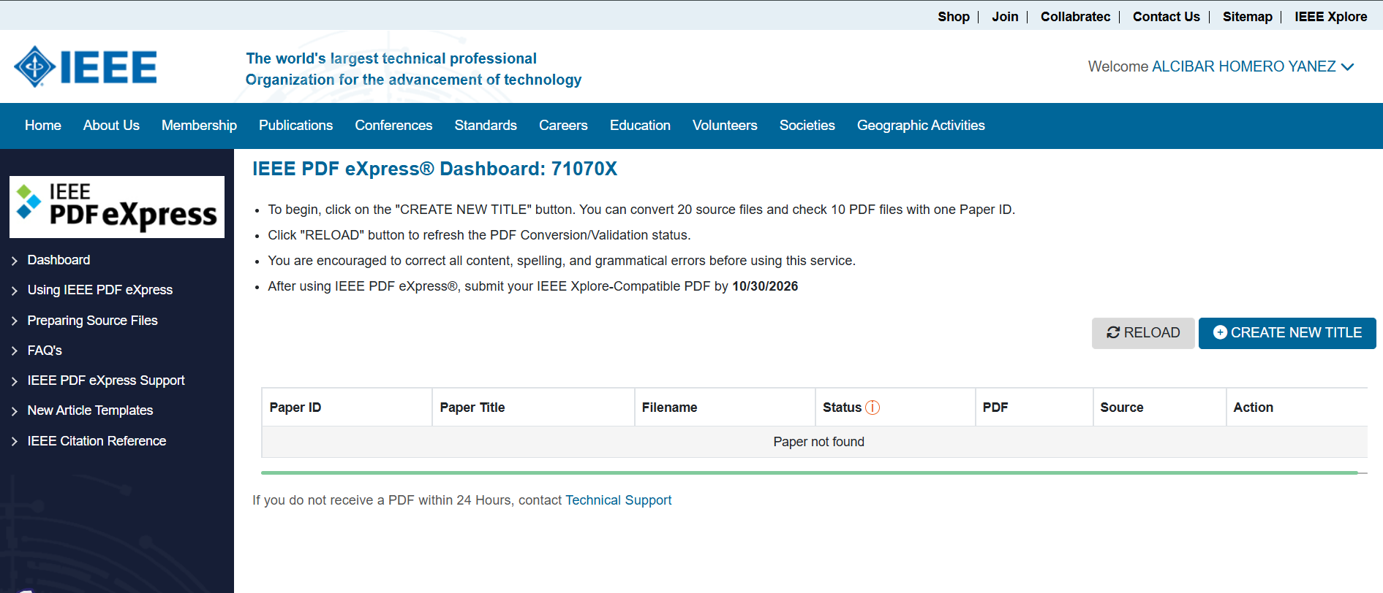

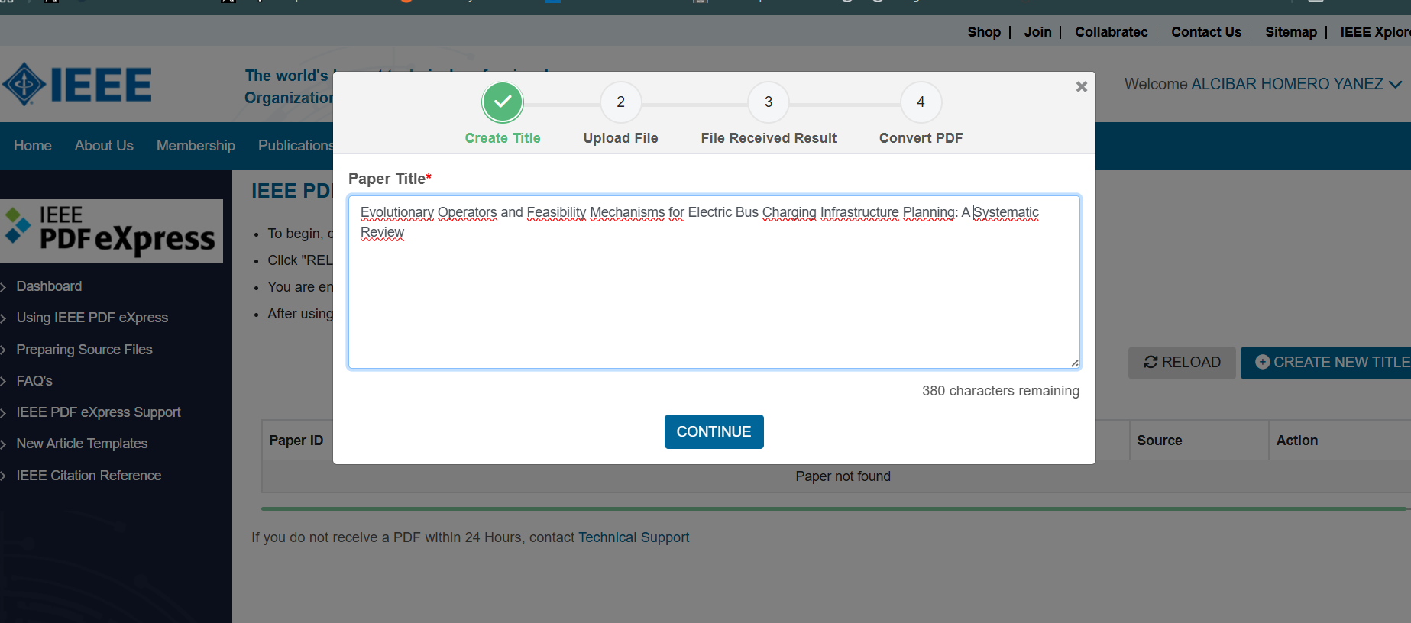

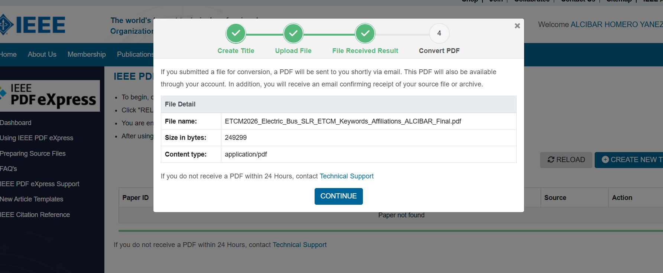

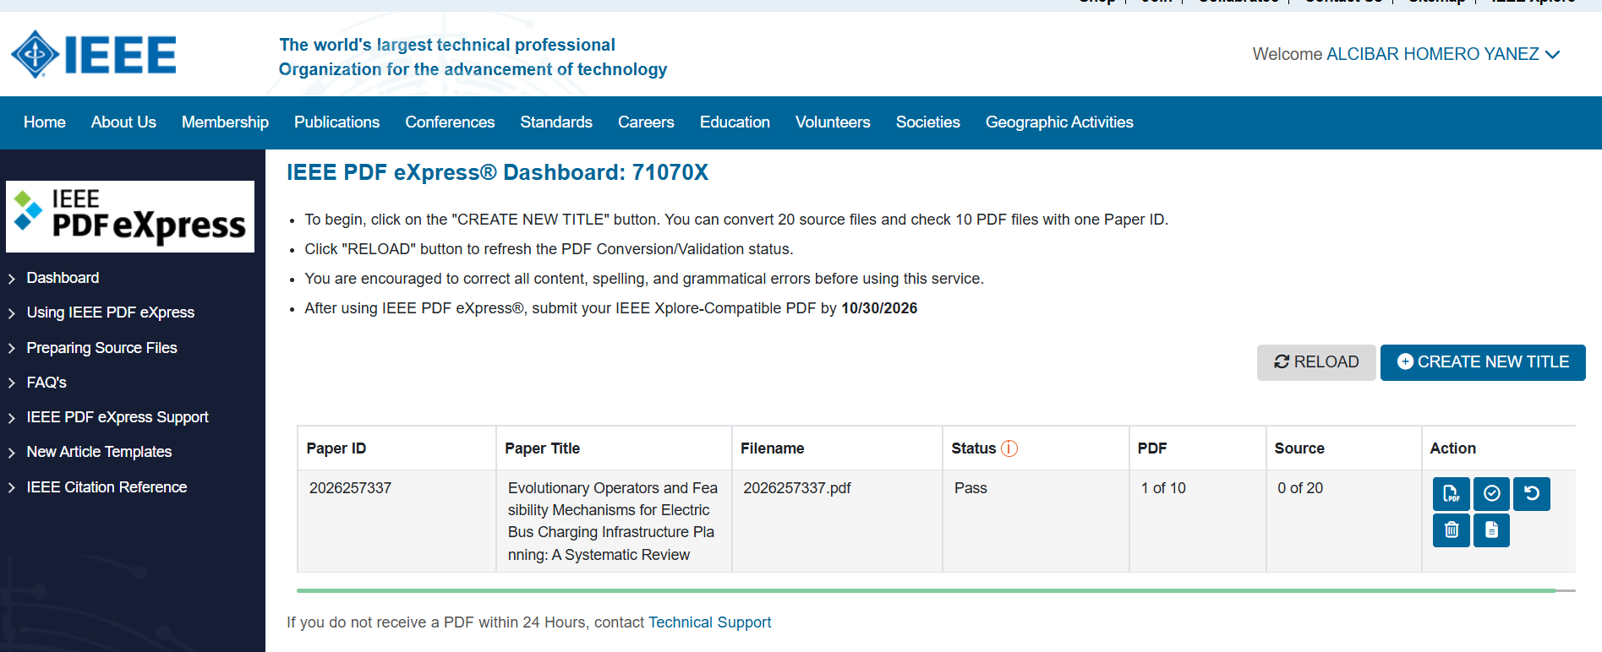
Authors will receive an email with the PDF generated by PDFeXpress. You can also download it from the icon highlighted in red.

If Failed, you have to download PDF Check report and resolve marked errors, then you must Try Again until Passed report. You have a limit of intents; try to resolve all errors at the same time.
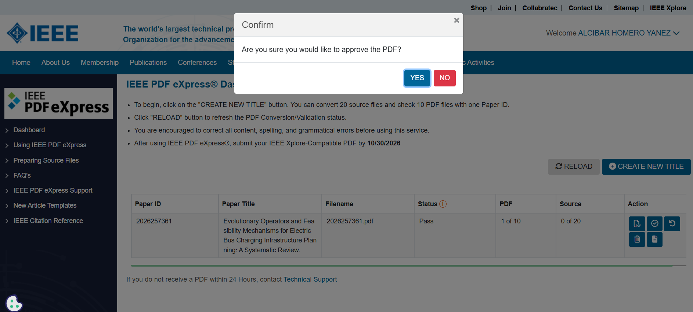

Passed result. Select Approve for Colletion, download PDF (in title link), and update it on easychair website.
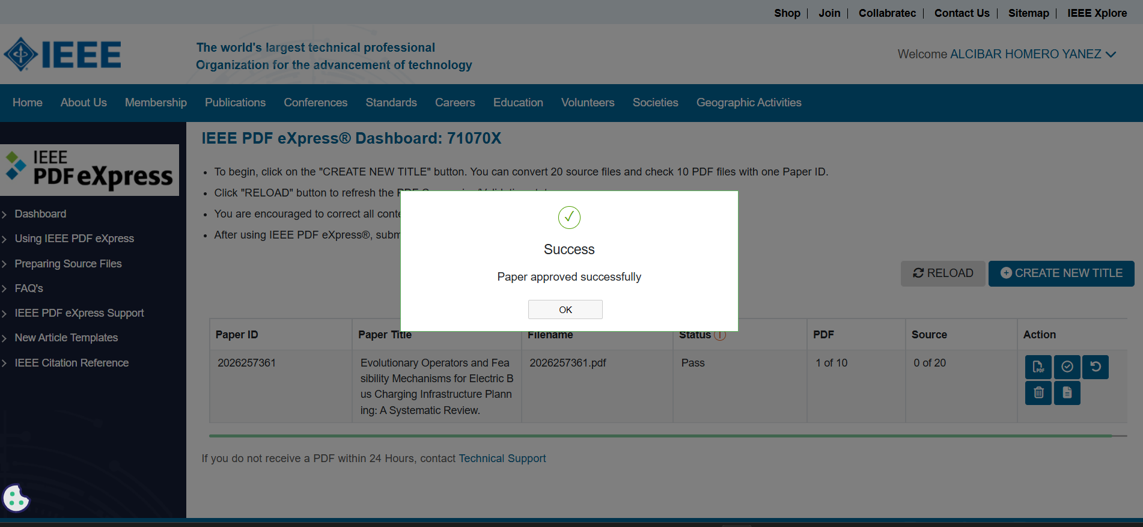

Phase 3. Final version submission on EasyChair.
The document generated in phase 2 must be uploaded to the Easychair platform. To do so, enter in Easychair and go to Final Version menu.
Accepted papers have Final Version Access Link from My Submissions menu or directly using “proceedings author (IEEE Proceedings)” role.
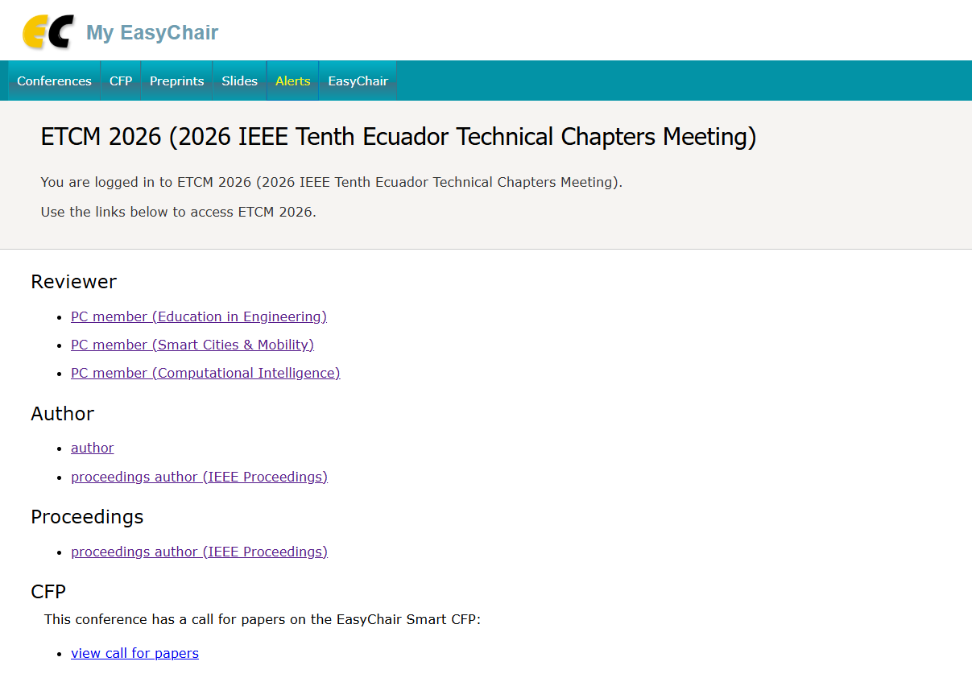

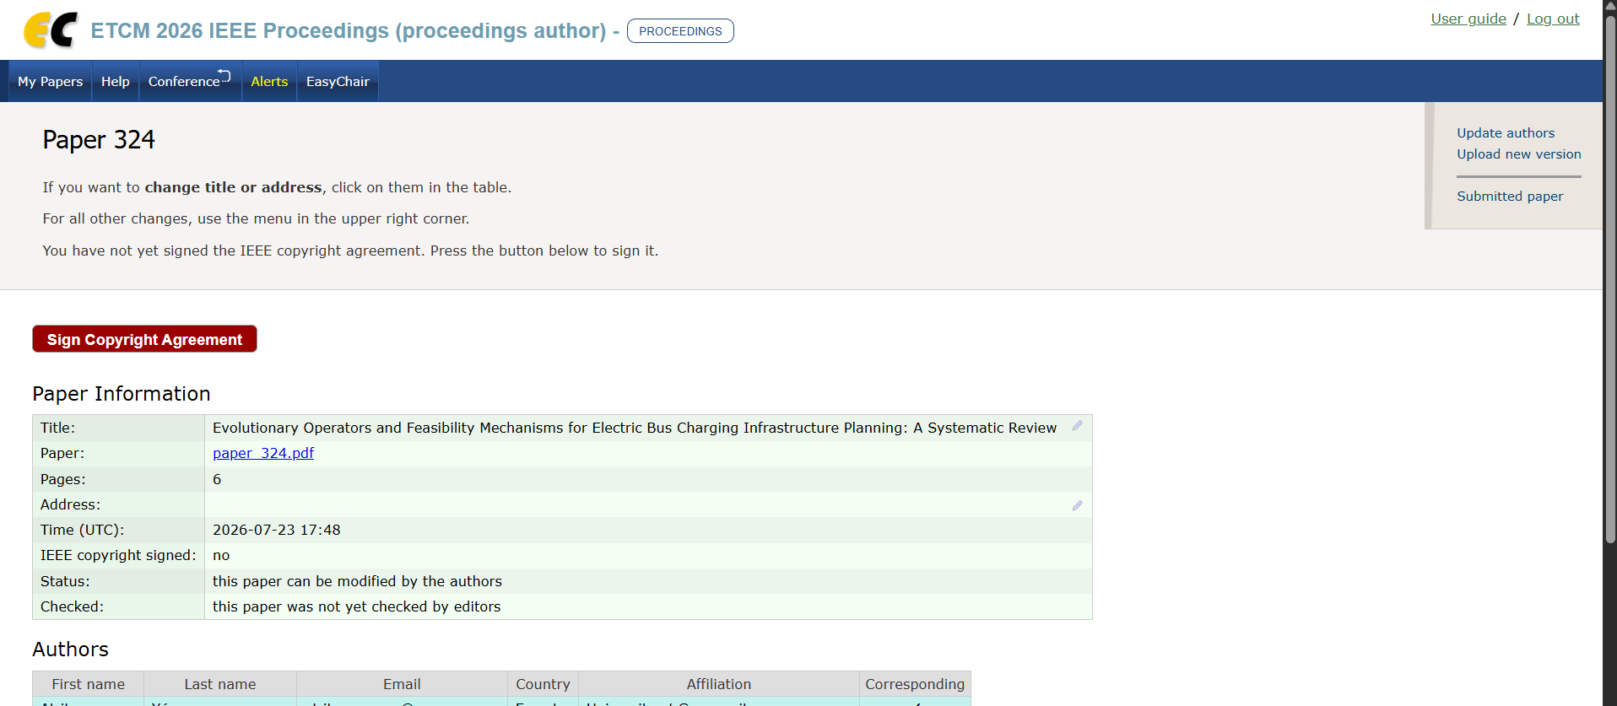

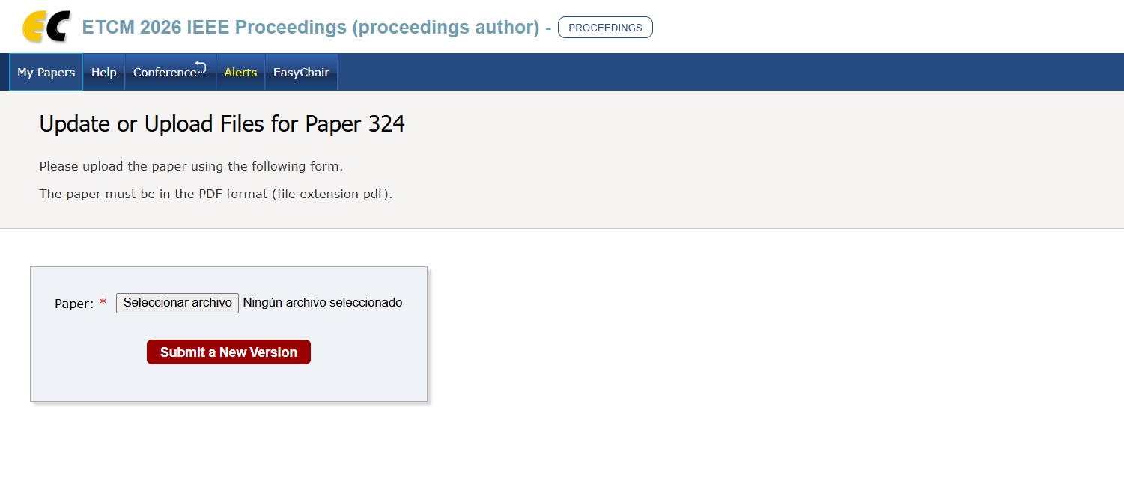

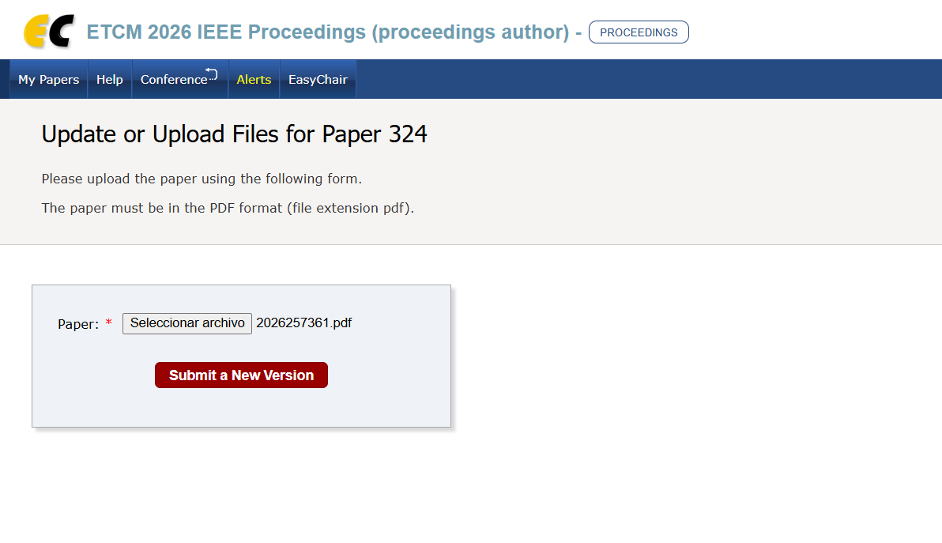

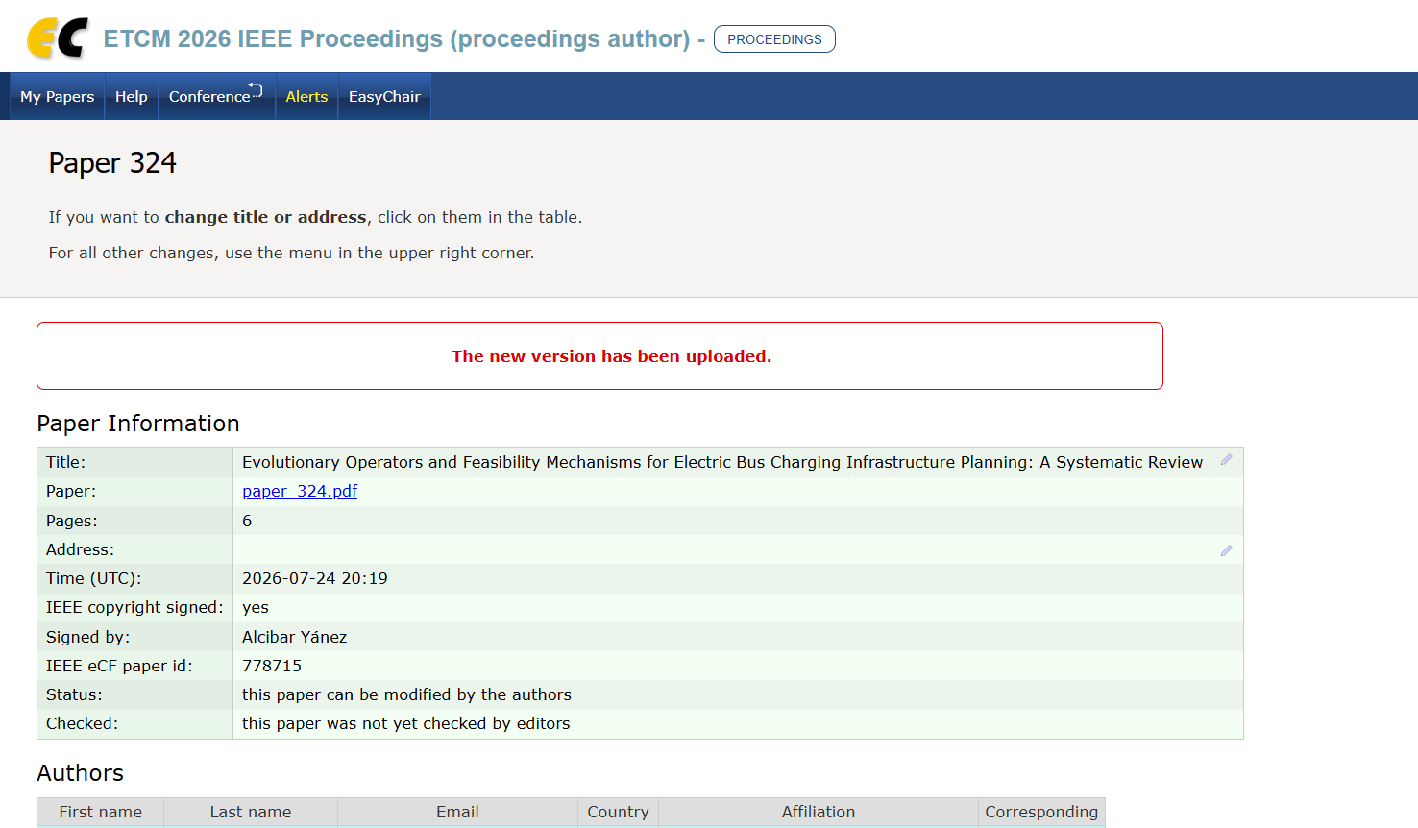

Phase 4. Copyright agreement signature.
Finally, appealing to the principles of transparency of the congress, we also kindly ask for filling the copyright section.


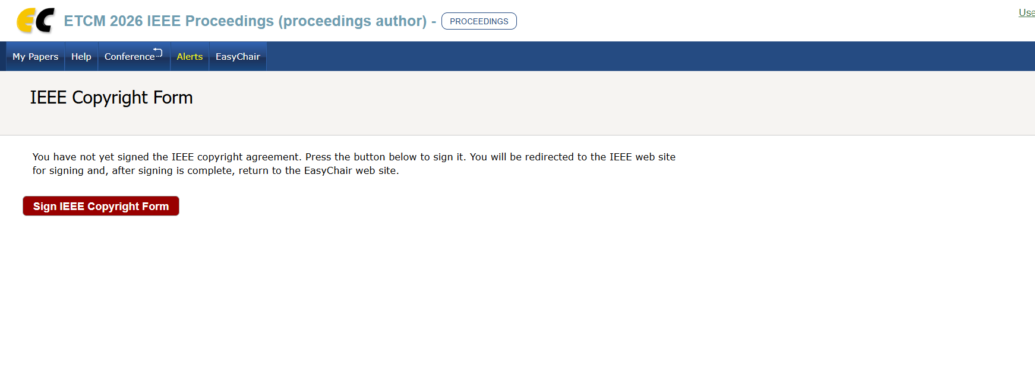

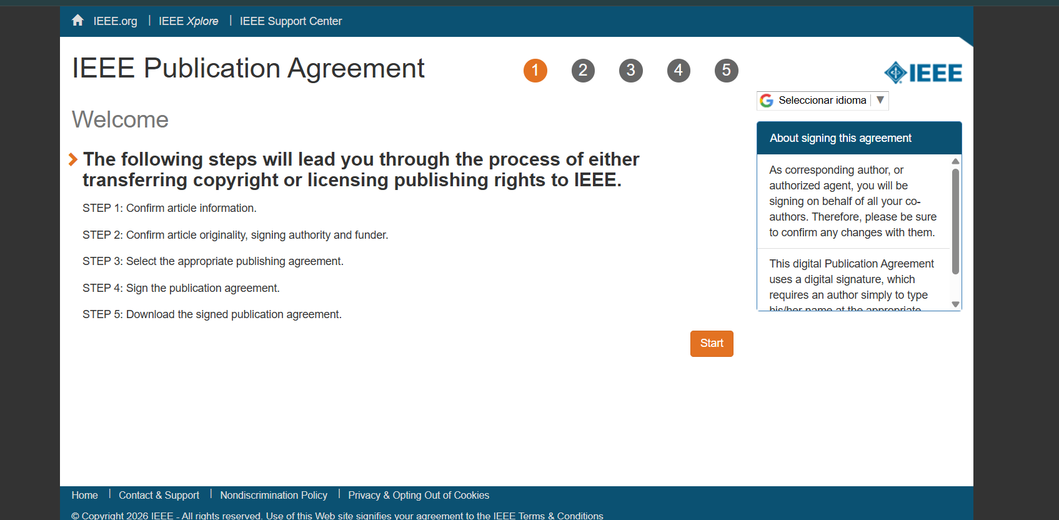

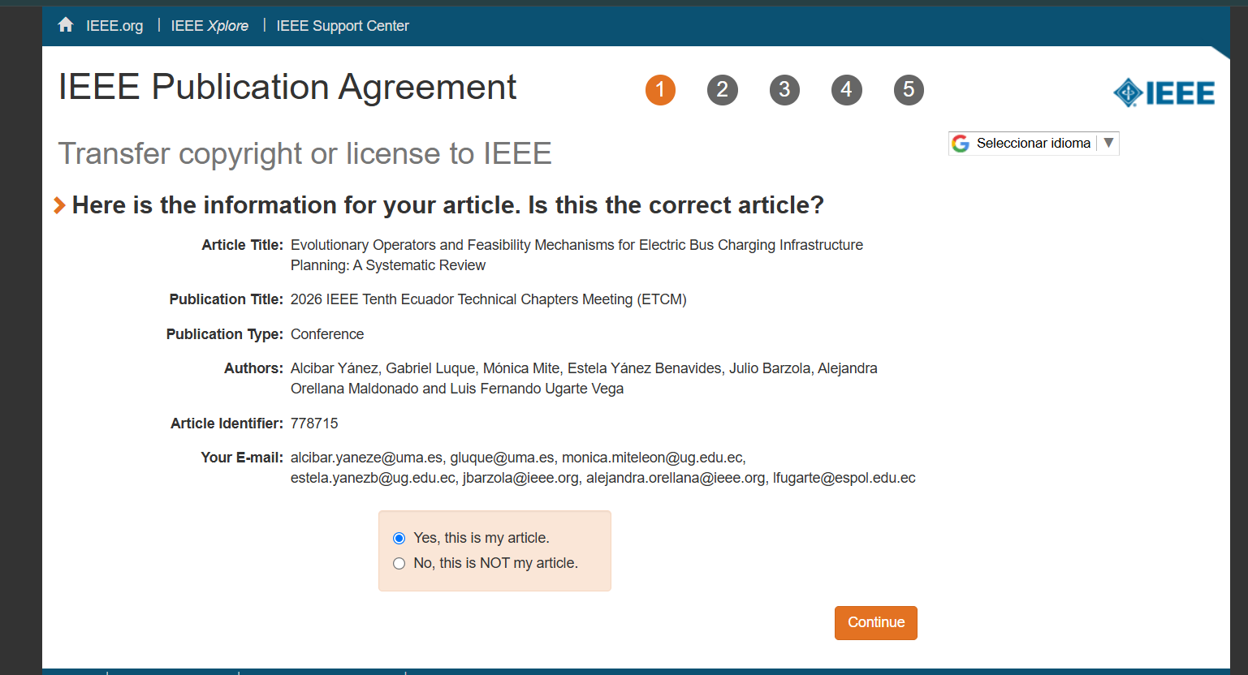

Article Title and Authors must be the same as in Easychair, in case of error, please update it in Easychair platform first and then start copyright form again.



